IMPLEMENTATION PLAN FOR M.Sc (HONS) DEGREE PROGRAM
OF LIVESTOCK MANAGEMENT DEPARTMENT

AT Findings | Corrective Action | Implementation Date | Responsible Body | Resources Needed
Criterion 1: (Vision Mission Objectives)  Program Mission Statement is not appropriate and needs to be revised. | Revision of Program mission statement. | Jan, 2012 | Program Team/ Chairman LM | Nil
Criterion 2: (Curriculum Design and organization):  The curriculum is not revised for last 5 years. | The Curriculum must be revised/reviewed. | 2013 | All faculty members of LM/Dean/Academic Council | Nil
Criterion 05:  (Process Control)  Process of enrollment should be evaluated periodically in consultation with the concerned department. | The department should be consulted during designing the entry test questions. | From next semester onward. | DAS&R/ | Nil
Criteria 7:  (Institutional Facilities)  Class rooms are insufficient | Directorate of Teaching should be contacted for provision of required number of classrooms. | As soon as possible | Chairman LM/ Director Teaching | Space and Well-equipped classrooms.
Criteria 7:  (Institutional Facilities)  No departmental Library. | Establishment of departmental library with sufficient number of Books, Journals, thesis etc. | 2012-2013 | Chairman/Dean | Space and books, journals etc.
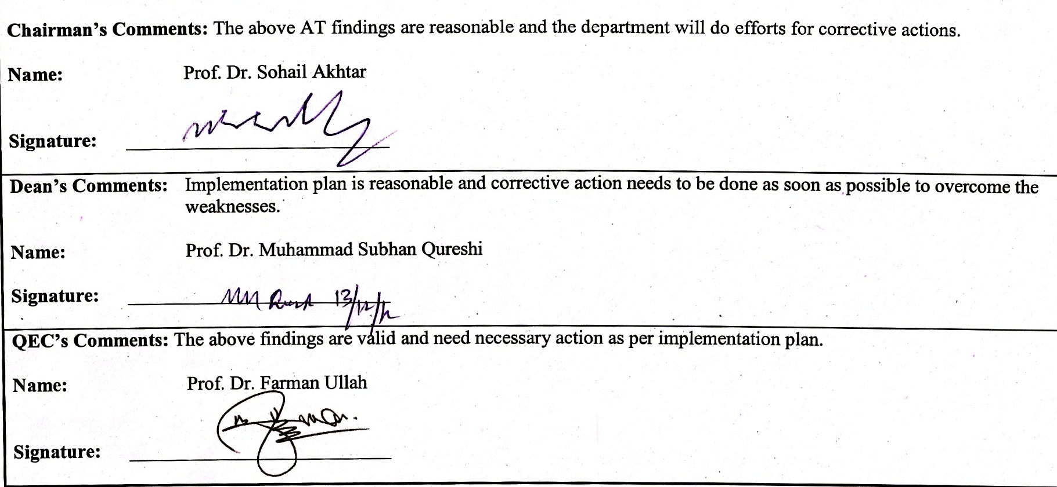

Chairman’s Comments: The above AT findings are reasonable and the department will do efforts for corrective actions.

Name: Prof. Dr. Sohail Akhtar

Signature: ___________________________

Dean’s Comments: Implementation plan is reasonable and corrective action needs to be done as soon as possible to overcome the weaknesses.

Name: Prof. Dr. Muhammad Subhan Qureshi

Signature: ___________________________

QEC’s Comments: The above findings are valid and need necessary action as per implementation plan.

Name: Prof. Dr. Farman Ullah

Signature: ___________________________

